CLASS 10 CHEMICAL REACTION AND EQUATION NOTES

Introduction of Chemical Reaction

*We have often seen that some substances when mixed form new substances.*  
*Like if we want to make tea, we add sugar, tea, milk and water. On heating, it turns into tea.*  
*Likewise, if you add a spoon of curd to lukewarm milk and keep it aside for few hours, then the whole milk turns into curd.*  
*We conclude that they thoroughly mix with each other and form a new substance. This thorough mixing is a chemical reaction.*

**Chemical Reaction**

**Definition:** When two or more substances react and form some new substance, it is called a chemical reaction.

**Let us see few activities related to chemical reaction:**

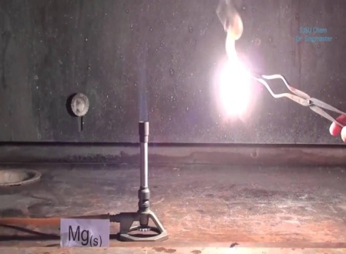

1. Burning of magnesium ribbon: the magnesium ribbon we bring has a layer of carbonate on it so before burning it needs to be cleaned with sandpaper.  
Products : magnesium oxide (white color_MgO)  
Identification property of reaction: white dazzling flame

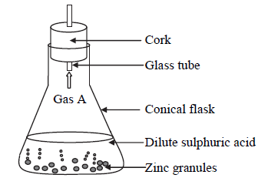

2.Reacting zinc granules with dilute sulphuric acid  
Chemical reaction : H2So4+Zn--- ZnSo4+H2  
Products : zinc-sulphate and hydrogen gas  
Identification: beaker becomes hot and hydrogen gas is produced which makes match stick burn with pale blue flame and popping sound.

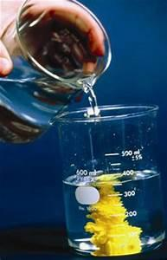

3.Reacting barium iodide with lead chloride  
Chemical reaction : BaI+PbCl2→BaCL2+Pb  
Products : barium chloride white color and yellow color precipitate of lead iodide.

[Top](https://www.successcds.net/Class10/science/chemical-reactions-equations.html#top)

Characteristics of a chemical reaction

1. It is either accompanied by a change in colour.
2. It either leads to a change in state.
3. Heat energy is produced or absorbed.
4. Precipitate is formed.
5. Gas is released.

[Top](https://www.successcds.net/Class10/science/chemical-reactions-equations.html#top)

Chemical Equation and Balancing

Chemical equation: it is the representation of chemical reaction in terms of symbols, molecular  
formulas, moles, states, etc.  
As we know, all chemical reaction obeys law of chemical combination. Therefore, chemical  
reactions need to be balanced. It is done by hit and trial method. (For practice, questions are  
solved in the end).

[Top](https://www.successcds.net/Class10/science/chemical-reactions-equations.html#top)

Types of chemical reactions

**We come across different types of reactions that occur in nature. Let us study about their type in detail :**

1. Combination reaction : when two or more reactants react to form a single product.

i.e A+B→AB (In this one single product is formed)  
This reaction can be between element - element, element - compound or compound -  compound.

|  |  |  |  |  |  |
| --- | --- | --- | --- | --- | --- |
| Like | H₂ | + | Cl₂ | ? | HCl |
|  | (E) |  | (E) |  | (Product) |
|  |  |  |  |  |  |
|  | SO₂ | + | O₂ | ? | SO₃ |
|  | (C) |  | (E) |  | (Product) |
|  |  |  |  |  |  |
|  | CO₂ | + | H₂O | ? | H₂CO₃ |
|  | (C) |  | (C) |  | (Product) |

Let us see an activity to demonstrate a combination reaction -  
Burning of magnesium ribbon is an activity of combination reaction  
Burning of magnesium ribbon: the magnesium ribbon we bring has a layer of carbonate on it so before burning it needs to be cleaned with sandpaper.  
Products : magnesium oxide (white color_MgO)  
Identification property of reaction: white dazzling flame

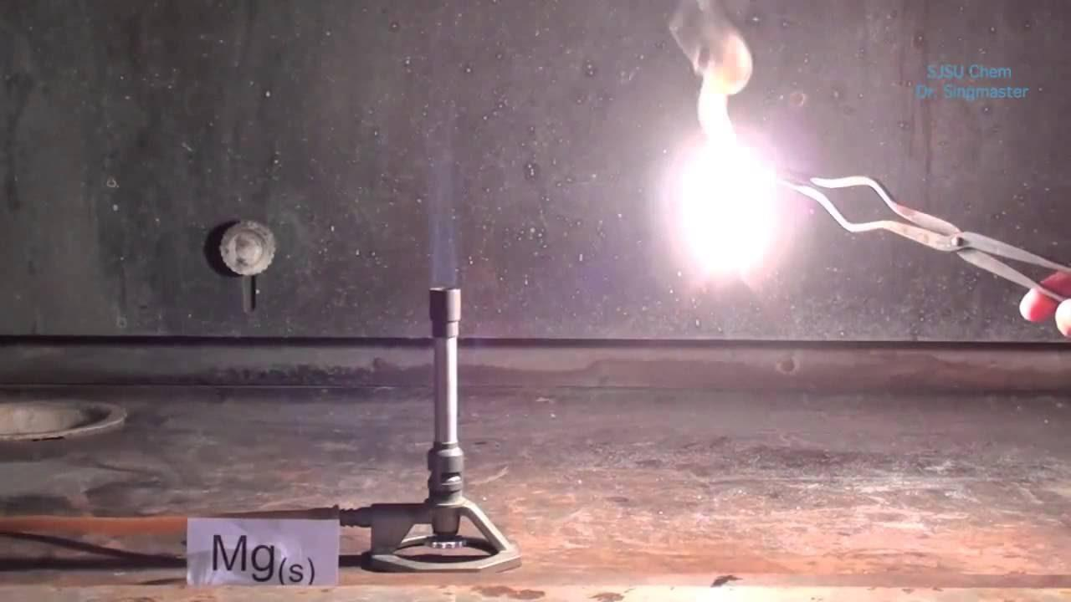

2. Decomposition reaction: it is the type of reaction in which a reactant breaks up into its constituents  either by heating or passing current or in presence of light.  
i.e.,

1. Photodecomposition (breaking in presence of light)

|  |  |  |  |  |  |
| --- | --- | --- | --- | --- | --- |
| example | AgCl | ? | Ag | + | Cl₂ |
|  | (white) |  | (grey) |  |  |

(b)Electrolytic decomposition : breaking by passing current

|  |  |  |  |  |  |
| --- | --- | --- | --- | --- | --- |
| example | NaCl | ? | Na | + | Cl₂ |

(c) Thermal decomposition : breaking by heating

|  |  |  |  |  |  |  |  |
| --- | --- | --- | --- | --- | --- | --- | --- |
| example | Pb(No₃)₂ | ? | PbO | + | NO₂ | + | O₂ |
|  |  |  |  |  | (reddish brown gas) |  |  |

Activity To Demonstrate : heating of ferrous sulphate  
FeSo4.7H2o→FeSo4+7H2O  
(green)  
FeSo4-   --heat → Fe2O3+So2+SO3

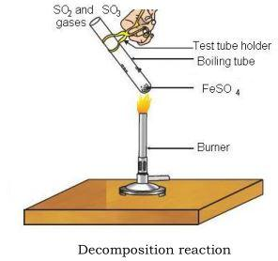

3. Displacement reaction : it is a reaction between element and a compound in which more reactive element displaces less reactive from its compound

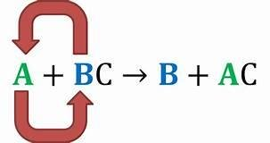

i.e.  
In this we follow reactivity series .  
Examples :

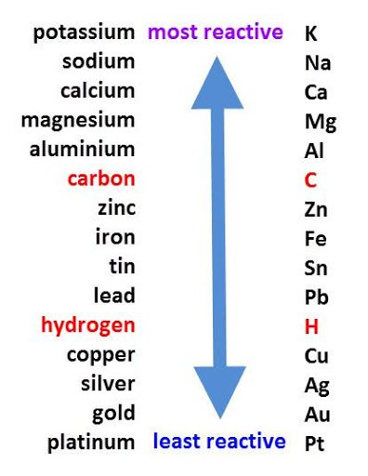

Activity To Demonstrate reaction of zinc granules with dilute sulphuric acid is an example of displacement reaction



Double decomposition or displacement reaction : it  is a reaction between two compounds in which they mutually exchange their ions.  
i.e.  
Examples :

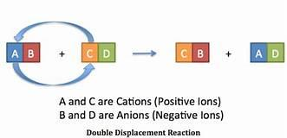

This is either precipitation reaction or neutralization reaction.  
**Precipitation reaction**: the reaction in which two compounds mutually react and leads to formation of insoluble substances called precipitates.

|  |  |  |  |  |  |  |
| --- | --- | --- | --- | --- | --- | --- |
| Bal | + | PbCl₂ | ? | BaCl₂ | + | Pbl₂ |
|  |  |  |  | (yellow colour) |  |  |

**Neutralization reaction** : a reaction in which two compounds react to form a neutral substance.  
i.e. Acid +Base →salt +Water  
   HCl+NaOH→NaCl+H2O  
Examples :

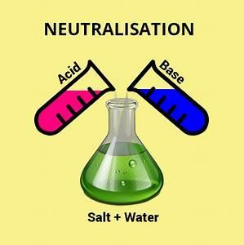

[Top](https://www.successcds.net/Class10/science/chemical-reactions-equations.html#top)

Redox Reaction- Rancidity and Corrosion

Redox -reaction: the reaction in which oxidation and reduction both occur simultaneously.  
Let us first learn about oxidation and reduction:

**On the basis of classical concept**  
Oxidation: addition of oxygen  or removal of hydrogen  
Mg+O2→MgO  
NaH→Na +H2  
Reduction: addition of hydrogen or removal of oxygen  
Na +H2 →NaH  
MgO→Mg+O2  
Oxidizing agent: which oxidizes other and itself gets reduced  
Reducing agent: which reduces others and itself gets oxidized .  
In the first example Na is reducing agent and in the second example Na is oxidizing agent

**On the basis of electronic concept**  
Oxidation: which donate electrons  
Reduction: which gains electrons  
Oxidising agent : the substance which oxidizes other and itself gets reduced  
In this equation -  Mg+O2→MgO  
Mg is reducing agent and O is oxidizing agent .  
Reducing agent : the substance which reduces other and itself gets oxidized

**Redox reaction :** A reaction in which both oxidation and reduction occur simultaneously

**Cuo +H2→Cu +H2O**  
In this, Cu (Oxidising Agent) Is getting Reduced And Hydrogen (Reducing Agent) Is getting Oxidised

**Daily life redox reactions : In daily routine we come across many RedOx reactions. Out of it we are going to learn about two important reactions :**

1. Rancidity
2. Corrosion

**Rancidity**

We have seen mostly in summers that if we keep any food item at room temperature for longer  
time, it becomes stale. It is due to  the oxidation of food when it comes in contact with air due  
to which it starts smelling bad and tastes bad. We can prevent it by taking few precautions like  
storing food in refrigerator. It will slow down the activity of microorganisms due to which their shelf life increases.  
Prevention :

1. Storing at low temperature
2. Adding preservative like salting, sugaring, nitrogen gas in potato chips, etc

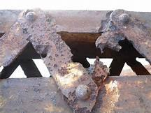

**Corrosion**  
it is eating away of metal article.  
In case of iron it is called rusting.

Conditions required : moist air  
Chemical reaction : fe+o2→Fe2o3.xH2o  
                                              (brown color rust)  
Prevention of rusting:  
(a) Painting  
(b) Lubricating  
(c) Galvanisation: it is the process of depositing thin layer of Zn on iron article. By doing it Zn prevent the reaction of iron with moist air.  
(d) Electroplating: by the process of electrolysis Cu and Cr layers are added on iron articles.  
(e) Alloying : we can use the alloy of iron i.e. stainless steel.

  Top

Chemical Reactions and Equations NCERT Book solutions

**Q1. Which of the statements about the reaction below are incorrect?  
2PbO(s) + C(s) → 2Pb(s) + CO2 (g)  
(a) Lead is getting reduced.  
(b) Carbon dioxide is getting oxidised.  
(c) Carbon is getting oxidised.  
(d) Lead oxide is getting reduced.  
(i) (a) and (b)  
(ii) (a) and (c)  
(iii) (a), (b) and (c)  
(iv) all**

A :(i)  (a) and (b)

**Q2. Fe2O3 + 2Al → Al2O3 + 2Fe  
The above reaction is an example of a  
(a) combination reaction.  
(b) double displacement reaction.  
(c) decomposition reaction.  
(d) displacement reaction.**

A : (d) Displacement reaction

**Q3. What happens when dilute hydrochloric acid is added to iron fillings?  
Tick the correct answer.  
(a) Hydrogen gas and iron chloride are produced.  
(b) Chlorine gas and iron hydroxide are produced.  
(c) No reaction takes place.  
(d) Iron salt and water are produced.**

A : (a)  Hydrogen gas and iron chloride are produced.

**Q4. What is a balanced chemical equation? Why should chemical equations be balanced?**

A :A balanced chemical equation is one in which the number of atoms taking part in the chemical equation are same i.e reactants, products on both sides of equation.  
It should be balanced because we know that mass can neither be created nor be destroyed it is always conserved.

**Q5. Translate the following statements into chemical equations and then balance them.  
(a) Hydrogen gas combines with nitrogen to form ammonia.  
(b) Hydrogen sulphide gas burns in air to give water and sulpur dioxide.  
(c) Barium chloride reacts with aluminium sulphate to give aluminium chloride and a precipitate of barium sulphate.  
(d) Potassium metal reacts with water to give potassium hydroxide and hydrogen gas.**

A:3N2 + H2 -->2NH3  
H2S+O2-->H2O + SO2  
3BaCl2+Al2(SO4)3-->2AlCl3+3BaSO4  
K+2H2O-->2KOH+H2

**Q6. Balance the following chemical equations.  
(a) HNO3 +Ca(OH)2 → Ca(NO3 ) 2 +H2O  
(b) NaOH + H2SO4 → Na2SO4 + H2O  
(c) NaCl + AgNO3 → AgCl + NaNO3  
(d) BaCl2 + H2 SO4 → BaSO4 +HCl**

A. (a) 2HNO3 +Ca(OH)2 → Ca(NO3 ) 2 +2 H2O  
(b) 2NaOH + H2SO4 → Na2SO4 + H2O  
(c) NaCl + AgNO3 → AgCl + NaNO3  
(d) BaCl2 + H2 SO4 → BaSO4 +2 HCl

**Q7. Write the balanced chemical equations for the following reactions.  
(a) Calcium hydroxide + Carbon dioxide → Calcium carbonate + Water  
(b) Zinc + Silver nitrate → Zinc nitrate + Silver  
(c) Aluminium + Copper chloride → Aluminium chloride + Copper  
(d) Barium chloride + Potassium sulphate → Barium sulphate + Potassium chloride**

A : Ca(OH)2+CO2-->CaCO3+H2O  
Zn +AgNO3-->Zn(NO3)2+Ag  
3Al+CuCl2-->2AlCl3+Cu  
BaCl2+K2SO4-->BaSo4+2KCl

**Q8. Write the balanced chemical equation for the following and identify the type of reaction in each case.  
(a) Potassium bromide(aq) + Barium iodide(aq) → Potassium iodide(aq) + Barium bromide(s)  
(b) Zinc carbonate(s) → Zinc oxide(s) + Carbon dioxide(g)  
(c) Hydrogen(g) + Chlorine(g) → Hydrogen chloride(g)  
(d) Magnesium(s) + Hydrochloric acid(aq) → Magnesium chloride(aq) + Hydrogen(g)**

A :2 KBr+BaI2-->2KI+BaBr2(double displacement)  
ZnCo3-->ZnO+CO2(decomposition)  
H2+CL2-->2HCl(combination)  
Mg+2HCl-->MgCl2+H2(displacement)

**Q9. What does one mean by exothermic and endothermic reactions? Give examples.**

A :Exothemic reactions : are those in whch heat is released  
Endothermic reaction: are those in which heat is absorbed

**Q10. Why is respiration considered an exothermic reaction? Explain.**  
Respiration is called exothermic reaction because in this the heat is evolved .

**Q11. Why are decomposition reactions called the opposite of combination reactions? Write equations for these reactions.**

A: Decomposition reactions are opposite to combination because in it, two or more reactants react to form single product whereas in decomposition, a reactant breaks up into its constituents  either by heating or passing current or in presence of light .  
H2+CL2------HCL(combination)  
HCL----H2+Cl2(decomposition)

**Q12.write one equation each for decomposition reactions where energy is supplied in the form of heat, light or electricity.**

A: (a)  Photodecomposition (breaking in presence of light )  
Example AgCl-----Ag+Cl2  
                       (white )  (grey )  
(B)Electrolytic decomposition : breaking by passing current  
Example : NaCl------Na+Cl2  
(c) Thermal decomposition : breaking by heating )  
Example : Pb(No3)2-----PbO+NO2+O2  
                                                                          (reddish brown gas)

**Q13. What is the difference between displacement and double displacement reactions? Write equations for these reactions.**

A: Displacement reaction : it is a reaction between element and a compound in which more reactive element displaces less reactive from its compound .  
AB+C-- AC+B

Double decomposition or displacement reaction : it  is a reaction between two compounds in which they mutually exchange their ions .  
AB+CD--AD+CB

**Q14. In the refining of silver, the recovery of silver from silver nitrate solution involved displacement by copper metal. Write down the reaction involved.**

A : Cu+AgNO3→ Cu(NO3)2

**Q15. What do you mean by a precipitation reaction? Explain by giving examples.**

A :Precipitation reaction : the reaction in which two compounds mutually react and leads to formation of insoluble substance called ppt.  
: BaI+PbCl2---BaCL2+PbI2  
                             (yellow colour)

**Q16. Explain the following in terms of gain or loss of oxygen with two examples each. (a) Oxidation (b) Reduction**

A: Oxidation : addition of oxygen  or removal of hydrogen  
Mg+O2→MgO  
NaH→Na +H2  
Reduction : addition of hydrogen or removal of oxygen  
Na +H2 →NaH  
MgO→ Mg+O2

**Q17. A shiny brown coloured element ‘X’ on heating in air becomes black in colour. Name the element ‘X’ and the black coloured compound formed.  
Cu+O2→ CuO**

A: X is Copper  
Black color compound is : copper oxide

**Q18. Why do we apply paint on iron articles?**

A : We apply paint on iron articles to prevent rusting

**Q19. Oil and fat containing food items are flushed with nitrogen. Why?**

A: Oil and fat containing food items are flushed with nitrogen to prevent rancidity.

**Q20. Explain the following terms with one example each. (a) Corrosion (b) Rancidity**

A: Corrosion : is eating away of metal article  
A reddish brown coating on iron nails after prolonged exposure to moist air is corrosion.

rancidity : it is due to  the oxidation of food when it comes in contact with air .Due to which it starts smelling bad and taste becomes bad .  
Food kept outside in summers becomes rancid.

**Extra Questions And Answers**

**1          Why should a magnesium ribbon be cleaned before burning in air?**

Ans.     Magnesium ribbon should be cleaned with sand paper to remove the protective layer of Magnesium carbonate so that it can readily combine with oxygen.

**2.         Why does colour of CuSO4 solution change when iron nail is dipped in it?**

Ans.     When iron nail is dipped in blue colour CuSO4 solution, colour fades because Iron displaces Cu to give solution of iron sulphate.  
Fe + CuSO4   →  FeSO4   + Cu  
        (Blue)

**3.         What is balanced chemical equation?**

Ans.     A balanced chemical equation is one in which number of atoms taking part in chemical equation are same i.e reactants, products on both sides of equation.

**4.         Why is respiration considered as exothermic reaction?**

Ans.     Respiration is considered an exothermic reaction because respiration means breakdown of glucose to produce energy required for metabolic reactions of body. As energy is released, it is called exothermic reaction.  
C6H12O6 + O2 → CO2 + H2O + Δ

**5.         Why is decomposition reaction called as opposite of combination reaction?**

Ans.     Decomposition reaction is called opposite of combination reaction because in decomposition a single substance decomposes to form two or more substances whereas in combination two or more substances combines to form a single substance.  
Ex.       CaCO3 → CaO + Co2 (decomposition reaction)  
Co2  + CaO → CaCO3 (combination reaction)

**6.         A shiny brown coloured element ‘X’ on heating in air becomes black in colour. Name the element ‘X’ & black coloured compound formed?**

Ans.     Element X  → Copper metal  
Cu + O2  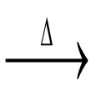 CuO  
(Brown)             (Black) copper oxide

**7.         Why do we apply paint on iron articles ?**

Ans.     We apply paint on iron articles in order to prevent rusting.

**8.         Oil  containing food items are flushed with Nitrogen. Why?**

Ans.     Oil containing food items are flushed with Nitrogen because these food items can become rancid after sometime due to oxidation & give bad smell & taste. In order to avoid this, they are flushed with nitrogen.

**9.         Suppose you burn Mg ribbon after cleaning it by sand paper & collecting product in water : - write colour of plane & name colour of compound formed?**

Ans:     (i) dazzling flame        (ii) magnesium oxide    (iii) Colour-white powder

**10.       How will you know that chemical reaction has occurred?**

Ans.     When chemical reaction occurs following changes can take place : - change in state, colour, temperature or evolution of gas or formation of precipitate.

**11.       What information do you get from:**  
**����������� CaCO3 + 2HCl → CaCl2 + H2O  + CO2**

Ans.     * Reactants are CaCO3 , HCl. Products are CaCl2 & CO2  
*  1 mole of Calcium carbonate reacts with 2 molecules of HCl to give 1 molecule of calcium chloride, water and carbon dioxide.

**12.       What happens when CO2 is passed through freshly prepared slaked lime? Give reaction.**

Ans.      Ca(OH)2  + CO2  → CaCO3  + H2O  
(slaked lime)

**13.       What is redox reaction? give example.**

Ans.     A reaction in which oxidation & reduction both take place simultaneously is called a redox reaction.  
Example - ZnO + O → Zn + CO

**14.       What type of  reactions  are represented by following: -**  
**X + Y  → X+ + Y-**  
**����������� X  + YZ ? XY + Z**  
**����������� X  ? Y + Z**  
**����������� X + Z ? ZX**

Ans. X + Y  → X+ + Y-  (oxide –red)  
X  + YZ → XY + Z  (displacement)  
X  → Y + Z   (decomposition)  
X + Z → ZX   ( Combination)

**15.       Give 2 examples of everyday life where redox reactions take place?**

Ans.     2 examples of everyday life where redox reactions take place are as follows -  
(i) Tarnishing of silver jewellery due to reaction with H2  
(ii) Rusting of iron

**16.       Consider the reaction -**  
**����������� NaOH + HCl ? NaCl + H2O**  
**Name type of reaction. Give it another name.**

Ans.     The reaction is Neutralization reaction.  
Another name for it is Displacement reaction.

**17.       Why moist air & acidic gases are not good for some metals?**

Ans.     Moist air & acidic gases are not good for some metals because moist air causes rusting of iron & acidic gases causes corrosion of copper & silver.

**18.       Why do we keep food in air tight containers?**

Ans.     We keep food in air tight containers to prevent food in coming contact with air to avoid its oxidation.

**19.       Why white colour silver chloride becomes grey when kept in sunlight?**

Ans.     White colour silver chloride becomes grey due to decomposition of silver chloride into silver and chlorine by light.  
           AgCl →  Ag   + Cl2  
(grey)

**20.       Why H2O2 is kept in coloured bottles?**

Ans. H2O2 is kept in coloured bottles because in presence of light H2O2 decomposes into water and oxygen. Therefore, it is kept in coloured bottles to cut off light.

�  
**21.       What type of colour is formed on copper articles when they get corroded?**

Ans.     Green colour of [ CuCO3 . Cu(OH)2].

**22.       Why we can’t store silver nitrate with copper spoon?**

Ans.     We can’t store silver nitrate with copper spoon because Cu reacts with silver nitrate to form copper nitrate.  
i.e. Cu + Ag NO3 → Cu(NO3)2 + Ag

**23.       Why colour of ferrous sulphate changes when it is heated?**

Ans.     FeSO4  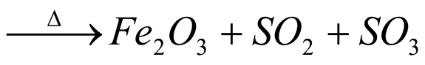    
(green)            (brownish black)  
Colour of ferrous sulphate changes when it is heated due to formation of  ferric oxide (brownish black is colour).

**24.       Why lime water is used to test presence of CO2 in lab? What happen when CO2 is passed through  lime water?**

Ans.     When CO2 is passed from lime water, it becomes milky.  
CO2  + Ca (OH)2   →  CaCO3  ↓ + H2O  
(Lime water)     (milky due to form of calc. carbonate.(white ppt).  
But when passed in excess then,  
Ca(OH)2  + CO2   → Ca(HCO3)2  
     (excess)  
White precipitate dissolves to form soluble calcium bicarbonate.

**25.       Write formula of lime, lime-water slaked lime?**

Ans.     Limestone –    CaCO3,  
lime     -           CaO,  
Slaked lime-    Ca(OH)2.